After completing this exercise, you should be able to:

* Measure DC current, DC voltage, and resistance using a workbench Digital Multimeter (DMM)
* Identify voltages and currents that are denoted by subscript notation
* Verify current measurements by applying Ohm’s Law

**Introduction**

Digital Multimeters are very common workbench equipment for testing and developing circuits, and computer hardware. Although most modern DMM can do many more types of measurement, we should be competent with their use for making basic measurements: resistance, voltage, and current.

We will begin directly measuring the currents flowing into and out of each of the five resistors in the circuit, and then also measure the of each resistor voltage drop, and the resistance of each resistor. Finally, you will calculate the value of each resistance with Ohm’s Law where each resistor current is found by IRn = (resistor voltage)/(resistance) and then check your work by confirming that the measured current and calculated current values are the same.

As for all technical work in this course, you are required to wear safety eye ware.

**Evaluation**

You are required only to submit the last page, along with verification by the instructor (again on last page of this document) in order to complete this exercise. Absence of instructor verification will result in a mark of zero for this activity.

**This activity is graded out of five marks. One mark will be deducted for each error or omission.**

**Part A. Direct measurement of the resistor input and output currents**

1. We will begin directly measuring the currents flowing into and out of each of the five resistors in the circuit. First, you will need to set up the DMM to measure DC current, and then, for each current measurement connect the DMM in series with part of the circuit. After each measurement, you must remove the DMM and restore the original connections for the measured component.
2. Construct the circuit shown in ***Figure 1.***, below:

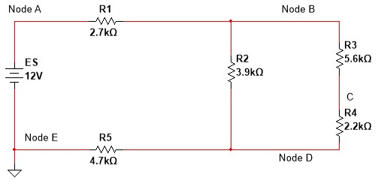

𝐼

𝑅

1



𝐼

𝑅

2



𝐼

𝑅

5



𝐼

𝑅

3



𝐼

𝑠



+



-



𝑉

𝑅

1



+



-



𝑉

𝑅

2



+



-



𝑉

𝑅

3



+



-



𝑉

𝑅

4



-



Node C

+

𝑉

𝑅

5

# Figure 1. Bread Board Circuit for Current Measurements

1. Make sure that the power supply is configured for 12 Volts, and its current limit is appropriate (slightly above the amount of current required to power the circuit, but not excessively so). The amount of current that should flow into the circuit can be easily predicted using Ohm’s Law:
   * 1. The calculated value of the total circuit resistance connected to the source (RT) is: ________
     2. The calculated value of the current flowing from the source (IS = IR1) is: ________
2. Now we will focus on how to measure current using a DMM. Begin by measuring the current flowing from the bench power supply through R1 (that is, the value of current IR1) using the procedure below.
3. **First configure the DMM to measure DC current:**
   1. First set the DMM power switch to the OFF position, and disconnect it from your circuit
   2. Connect the red test lead to the DMM banana lead receptacle that is labelled “I”, which is also coloured red (this is the connection for current entering the DMM), see ***Figure 2.***, below.
   3. The black lead should be connected into the banana lead receptacle on the DMM that is labelled

“LO”, also shown in ***Figure 2.*** below

* 1. Connect the red and test leads to the circuit (alligator clip ends) such that the meter is in series with the portion of the circuit where you want to measure current
  2. Use the front panel push buttons to enter the current measurement mode
  3. Set the power switch to the ON position

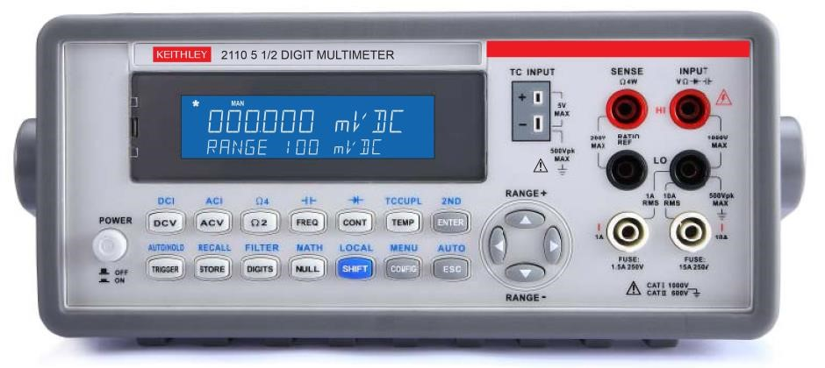

Black Lead

Red Lead

# Figure 2. Front Panel of Keithley DMM – Connections for Measuring Current

1. **Safety Warning:**
   * **WHEN MESURING CURRENT, DO NOT CONNECT THE DMM IN PARALLEL WITH A COMPONENT**

**OR AN ENERGY SOURCE**

o **This will give an incorrect measurement and can be harmful to the circuit, or cause personal injury in cases involving high current power sources**

* + Note that *insertion resistance of the DMM is almost zero Ohms*, such that the meter will represent a short circuit (low resistance) when set up to measure current
  + Never connect a DMM *across* the terminals of a power source (*especially batteries*) when it is configured to measure current, measuring current from a power source is safe however if it is connected in series
  + The current measurement connections are protected by internal *fuses* that protect it from excessively high currents that would otherwise damage it
  + The low insertion resistance of a DMM in current mode can result in very high current, if connected improperly to an energized circuit
  + Be mindful when measuring current: energy sources may exceed the interrupting ability of internal fuses in some circumstances such as when working with some energy sources (like batteries)
  + our bench power supplies can generate 3 Amps if the current limit is set to maximum (although the current limit should set to a lower value, by default)
  + although quite safe if used properly, bench power supplies can deliver enough power to dramatically heat wires and components that can cause burns or cause components to explode sand throw debris towards you at high speed; this is a reason to wear CSA rated safety glasses

1. Now use the DMM to measure the current (IR1) that flows through R1 from Node A, by performing the following actions to modify the circuit as shown in ***Figure 3.***, below:
   1. Ensure that the power supply is turned off and that the DMM is disconnected from the circuit
   2. Pull out the R1 lead that is connected to Node A
   3. Connect the black (LO) lead of the DMM to the end of the resistor (that is, the disconnected lead of the resistor)
   4. Connect the red (I) lead to a piece of hook-up wire and plug the hook-up wire into the breadboard hole out of which you just pulled the R1 lead

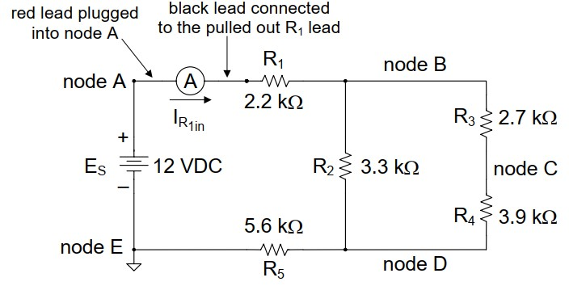

# Figure 3. – Modification Circuit for Measuring Current IR1

1. By performing these actions, you have modified the circuit as shown in ***Figure 3.***, above. The DMM configured for DC current measurement is represented by a symbol that looks like a circle containing the letter “A”, which is a standard schematic symbol for an ammeter.
2. We expect that IR1 flows in the direction shown by the arrow in ***Figure 3***., therefore the DMM has been connected so that the expected current will flow into its “I” terminal (red lead) from Node A and out of its “LO” terminal (black lead) to R1. If the current does flow in this direction (as it should), the DMM will display a positive value, but if it flows the other direction, then it will display a negative value. This is not harmful to the DMM.
3. Try connecting the banana connector end of the test leads to the DMM such that the red lead is in the black terminal “LO” and the red lead is in the “I” terminal receptacle. You should now see that the value displayed on the DMM is negative, meaning that current is flowing in the opposite direction. After verifying this, reconnect the leads into their original position.
4. Now that you are finished measuring IR1, perform the following actions:
   1. Turn off the power supply
   2. Disconnect the DMM from the circuit and plug the pulled-out R1 lead back into its original breadboard hole.
5. Once you are confident that you can measure current IR1, continue by measuring the current through the remaining resistors. Record these values in ***Table 1.***, below, because you will need them later. Record all digits in the measurement which are stable (unchanging) on the display. Note that these values will be used for calculations that you will perform later on in this exercise, so they should be recorded with the same number of digits that are displayed on the DMM.

*Often, the last digit on a DMM does not stay constant and continues to change before you can write it down. So, you may wonder how to determine what the best value is.*

*When measuring values record only the digits on your DMM that are stable (i.e., unchanging). Or, if you wish you may estimate this last digit (using your best guess) and then round the next digit to the left up if the estimated least significant it is larger than 4.*

|  |  |
| --- | --- |
| **Current Designator** | Measured  Current  Value  (Amps) |
| IR1 | 1.2077mA |
| IR2 | 0.8059mA |
| IR3 | 0.4023mA |
| IR4 | 0.4023mA |
| IR5 | 1.208mA |

# Table 1. Measured Resistor Currents

To receive a mark for this exercise, you must demonstrate your ability to measure a current of the instructor’s choosing. Otherwise, your mark on will be zero regardless of the other work that was submitted.

Instructor Verification:_________

1. We should not be surprised that measuring the current through R4 isn’t necessary, since R3 and R4 are in series such that IR3 = IR4.
2. **WARNING:**
   * After you are finished making several current measurements, a common mistake is to forget to re-configure a DMM for your next type of measurement (What might happen???)
   * Be mindful to re-connect the DMM as appropriate for the next type of measurement before proceeding
     1. turning off the power supply
     2. removing test leads from the circuit (alligator end of each lead)
     3. removing the red lead from the current measurement banana receptacle “I” on the DMM, and connect it to the terminal for measuring voltage
     4. set the front panel controls to do the next type of measurement
     5. connect leads to the circuit again as appropriate
     6. energizing the power supply (turn it on with power switch)
3. You may apply KCL, or other methods of analysis to verify that the current measurements in Table 1, are sensible.

**Part B – Resistance, and DC Voltage Measurements**

1. Now you will measure the voltages in the circuit, the resistance of each resistor and apply Ohm’s law to determine the current a second time by using Ohm’s Law. By comparing the currents you measured in Part A to the calculated values, you will be able to verify the accuracy of your current measurements by noting if the calculated and measured values are similar.
2. Use the DMM to measure and record the voltages indicated in Column 1 in Column 3 of ***Table 2***, below.
3. Copy the values of the currents you measured from ***Table 1***, above into Column 8 of ***Table 2***, below.
4. Now measure the resistance of each resistor and enter these values in Column 5.
   * **Note: measuring the resistance of a resistor while it is connected to the rest of the circuit will give the incorrect value.**
   * Each resistor must first be isolated from the circuit before measuring its value. Otherwise, the DMM will measure a resistance that results from a combination of the other resistors in the circuit.
   * Be sure to either remove (or disconnect each resistor at one end) to measure its value.
   * Again, when measuring resistor values record only the digits on your DMM that are stable (i.e., unchanging). Or, if you wish you may estimate this last digit (using your best guess) and then round the next digit to the left up if the estimated least significant it is larger than 4.

|  |  |  |  |  |  |  |  |  |
| --- | --- | --- | --- | --- | --- | --- | --- | --- |
| **Column 1** | **Column 2** | **Column 3** | **Column 4** | **Column 5** | **Column 6** | **Column 7** | **Column 8** | **Column 9** |
| **Measured Voltage**  **(Identifier)** | **Resistor**  **Voltage**  **Drop**  **(Identifier)** | **Measured**  **Voltage**  **Drop**  **(Volts)** | **Resistor Designator** | **Measured**  **Resistance**  **(Ohms)** | **Current**  **Identifier**  **(Amps)** | **Calculated**  **Current**  **(Amps)** | **Measured**  **Current**  **From**  **Above**  **(Amps)** | **Error (%)** |
| VCB | **-VR3** | -2.24 V | R3 | 5.6 kΩ | IR3 | 400 μA | 424.52 μA | 6.13 |
| VAB | VR1 | 3.2338 V | R1 | 2.674 kΩ | IR1 | *1.20 mA* | *1.20 mA* |  |
| VBD | VR3 + VR4 or VR2 | 3.1152 V | R3 + R4 | 7.737 kΩ | IR3, or IR4 | *400 μA* | *400 μA* |  |
| VDC | -VR4 | -0.88341 V | R4 | 2.193 kΩ | -IR3, or -IR4 | *-400 μA* | *-400 μA* |  |
| VDE | VR5 | 5.6502 V | R5 | 4.673 kΩ | IR5 | *1.20 mA* | *1.20 mA* |  |
| VEA | -ES | -12.001 V | RT | 9.925 kΩ | -IS | *1.20 mA* | *1.20 mA* |  |

# Table 2. Table of Results

1. In Column 6, enter the identity of the measured current flowing through each resistance (as a variable).
2. Using the measured resistances (Column 5) and the voltage drops (Column 3), calculate the amount of current flowing through each resistor using Ohm’s Law to calculate the current values in Column 7 of ***Table 2***, above.
3. Calculate the percentage of error between the values of current you measured directly (Column 8), and the values determined by Ohm’s Law (Column 7), and it in Column 9.

*You should already be familiar with percentage error calculations from prior learning; this is only a reminder.* In this case, he general form of a percentage error calculation is shown below:

|𝐶𝑎𝑙𝑐𝑢𝑙𝑎𝑡𝑒𝑑 𝑉𝑎𝑙𝑢𝑒 − 𝑀𝑒𝑎𝑠𝑢𝑟𝑒𝑑 𝑉𝑎𝑙𝑢𝑒|

%𝐸𝑟𝑟 =

𝐶𝑎𝑙𝑐𝑢𝑙𝑎𝑡𝑒𝑑 𝑉𝑎𝑙𝑢𝑒

*Note:* If the percentage error is higher than expected for a particular current, then you should check your measurements and calculations for errors and resolve the error.

1. **Now that you have completed the measurements portion, complete *Table 2.* above by entering the rest of the missing information. The first row has been done for you as an example.**
   * Column 2: identify the resistor voltages that comprise each voltage as variable (ex. -VR3)
   * Column 6: identify the current that flows through the resistors as a variable (ex. -IR2)
   * Column 7: calculate the value of the current using Ohm’s Law, based on the measured values of component voltages and resistance

A Mobius version of this page is available so that you can record your answers. However, this page may be printed (or edited electronically) for submitting your work:

|  |  |  |  |  |  |  |  |  |
| --- | --- | --- | --- | --- | --- | --- | --- | --- |
| **Column 1** | **Column 2** | **Column 3** | **Column 4** | **Column 5** | **Column 6** | **Column 7** | **Column 8** | **Column 9** |
| **Measured Voltage**  **(Identifier)** | **Resistor**  **Voltage**  **Drop**  **(Identifier)** | **Measured**  **Voltage**  **Drop**  **(Volts)** | **Resistor Designator** | **Measured**  **Resistance**  **(Ohms)** | **Current**  **Identifier**  **(Amps)** | **Calculated**  **Current**  **(Amps)** | **Measured**  **Current**  **From**  **Above**  **(Amps)** | **Error (%)** |
| VCB | **-VR3** | -2.24 V | R3 | 5.6 kΩ | IR3 | 400 μA | 424.52 μA | 6.13 |
| VAB | *VR1* | *3.24 V* | *R1* | *2.7 kΩ* | *IR1* | *1.20 mA* | *1.20 mA* |  |
| VBD | *VR3 + VR4 or VR2* | *3.12 V* | *R3 + R4* | *7.8 kΩ* | *IR3, or IR4* | *400 μA* | *400 μA* |  |
| VDC | *-VR4* | *-880 mV* | *R4* | *2.2 kΩ* | *-IR3, or -IR4* | *-400 μA* | *-400 μA* |  |
| VDE | *VR5* | *5.64 V* | *R5* | *4.7 kΩ* | *IR5* | *1.20 mA* | *1.20 mA* |  |
| VEA | *-Es* | *-12 V* | RT | *10 kΩ* | *-IS* | *1.20 mA* | *1.20 mA* |  |

To receive a mark for this exercise, you must demonstrate your ability to measure a current of the instructor’s choosing. Otherwise, your mark on will be zero regardless of the other work that was submitted.

Instructor Verification:_________